HW1: Mid-term assignment report

*Joao Santos[110555]*, v09

1 Introduction 1

1.1 Overview of the work 1

1.2 Current limitations 1

2 Product specification 2

2.1 Functional scope and supported interactions 2

2.2 System architecture 2

2.3 API for developers 2

3 Quality assurance 3

3.1 Overall strategy for testing 3

3.2 Unit and integration testing 3

3.3 Functional testing 6

3.4 Code quality analysis 6

3.5 Continuous integration pipeline [optional] 7

4 References & resources 7

# Introduction

## Overview of the work

This report presents the midterm individual project required for TQS, covering both the software product features and the adopted quality assurance strategy.

The main purpose of BusConnection Application is to provide users with the ability to

Query bus connections between specific origin and/or destination locations, along with

filtering options such as departure date and currency. They can also book reservations choosing what seat they want and check them with the token generated.

## Current limitations

About limitations, I tried to implement a persistence database, but I couldn´t, I´ve tried with SQL, with PostgreSQL, with hibernate but my application never connected to the database server, so I gave up and use spring hibernate non persistent database. So, whenever I shutdown the Spring Application I lose all progress on the database.

Also, I’m using spring cache to store the API information, so the cache is emptied every time Spring Application is shut downed.

# Product specification

## Functional scope and supported interactions

The main usage scenario is a regular person that has interest in travelling from Lisbon to Porto by bus and wants to book a ticker online. For that the person will fill the from with the origin and destination and see the available trips. Then the person will book the reservation and reserve a seat. A token will be generated, and the person must save it. Then if the person wants to check their reservation, he must use the token previously generated.

## System architecture

The application can be divided into 2 big parts, front-end and back-end.  
  
The front-end was made via HTML, CSS and JS.

The backend was developed with Spring boot, and it has a controller layer to communicate with the front end. The service layer to handle the service logic and functions. The repository layer to have functions to interact with the database. The entity layer to create the entities and provide a definition for the database table. The component layer that has some data initialization and some functions to help the internal system.

To launch the application run mvn spring-boot:run and access the port http://localhost:8080.

## API for developers

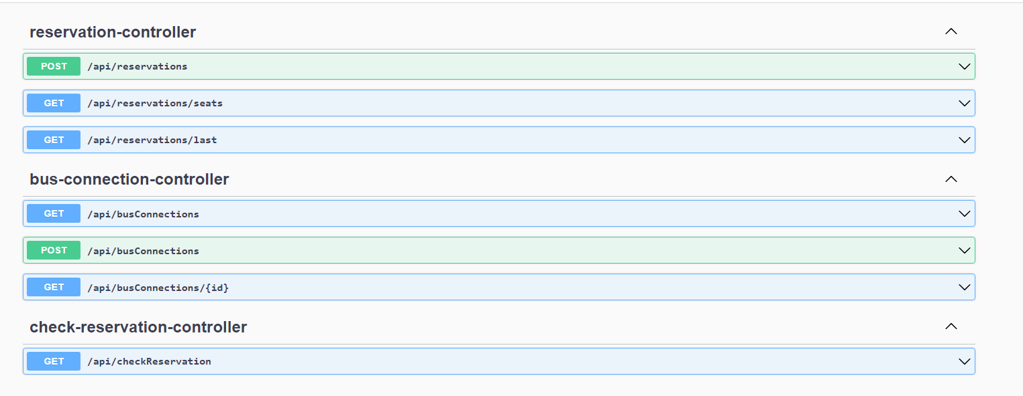

This API documentation can be accessed through <http://localhost:8080/swagger-ui/index.html.´>

The schemas are also present.

# Quality assurance

## Overall strategy for testing

Since the application was organized in layers, I used integration tests to test a single layer component to then start another one. For that I used mocks and simulate the behavior of the layers that were not implemented yet. I also used cucumber

## Unit and integration testing

As unit tests I tested some validate functions when initializing the entities such as valid phone number or email address.

After that I went on a multi-layer application test were I mock the behavior of some layers and test internal functions of a single layer. When I’ am assured that the layer is tested I start developing the next layer.

## Functional testing

## Code quality analysis

For code quality analysis first used only Jacoco to see what part of the code was I covering with the tests and after most of the tests were done I used SonarCloud to see more detailed analysis on my tests results and I fixed a lot of things.

The security Hotspot caught on the SonarCloud is due to the exposing of the currency API key (which I don’t mind being exposed to).

The 56 maintainability issues are due to package names or public functions mostly and I don’t see that as a impactful issue.

For the coverage I have a 93 % coverage which I consider being ok. When I looked up for the parts of the code that were not being covered, I didn’t noticed anything of big importance.

There were a total of 61 tests made on this application

## Continuous integration pipeline [optional]

# References & resources

Project resources

|  |  |
| --- | --- |
| **Resource:** | **URL/location:** |
| Git repository | https://github.com/JotaCLS/TQS_110555 |
| Video demo | Video included in git repository |
| QA dashboard (online) | I runned sonar locally via docker |
| CI/CD pipeline | [**optional**; if you have th CI pipeline definition in a server, place the URL here] |
| Deployment ready to use | [**optional**; if you have the solution deployed and running in a server, place the URL here] |

Reference materials

<https://currencyapi.com> – For the currency API